TRN Resource: Critical Functions

Introduction
The Technical Resilience Navigator (TRN) guides users through the resilience planning process at sites. The units of analysis for the TRN risk assessment are critical loads, which are energy or water loads that are required to support critical functions and can be impacted by a disruption to energy or water supply systems. Within the TRN, users first identify the critical missions at the site and the critical functions—or operations and activities required to enable a critical mission—before identifying the critical load. This document aims to support users in this preliminary step of understanding and identifying critical functions and provides reference examples. By providing additional guidance on the critical function identification process, this resource aims to reduce the time and effort required to complete this Site-Level Planning action.

The Relationship Between Critical Missions and Critical Functions
Within Site-Level Planning Action 4, users first identify the site’s critical missions. The TRN defines critical missions as a “mission of such high importance that its incapacitation or destruction would have a severely degrading effect on the ability of the agency to execute the tasks or mission-essential tasks it supports in all operating environments.” (TRN 2022). Another way to think about critical missions is that they represent the site’s reasons for existing. However, if there is a pre-existing definition of critical missions specific to the site, TRN users should use that definition. Frequently, sites have more than one mission; users should work to identify if all missions are considered critical and exclude those that are not from analysis.
Next, users identify the critical functions that support each critical mission. The TRN defines critical functions as “the operations and activities required to enable a critical mission” (TRN 2022). A schematic of how critical missions and functions are connected is shown in Figure 1. To follow best practices, take time to define your critical missions before identifying critical functions.
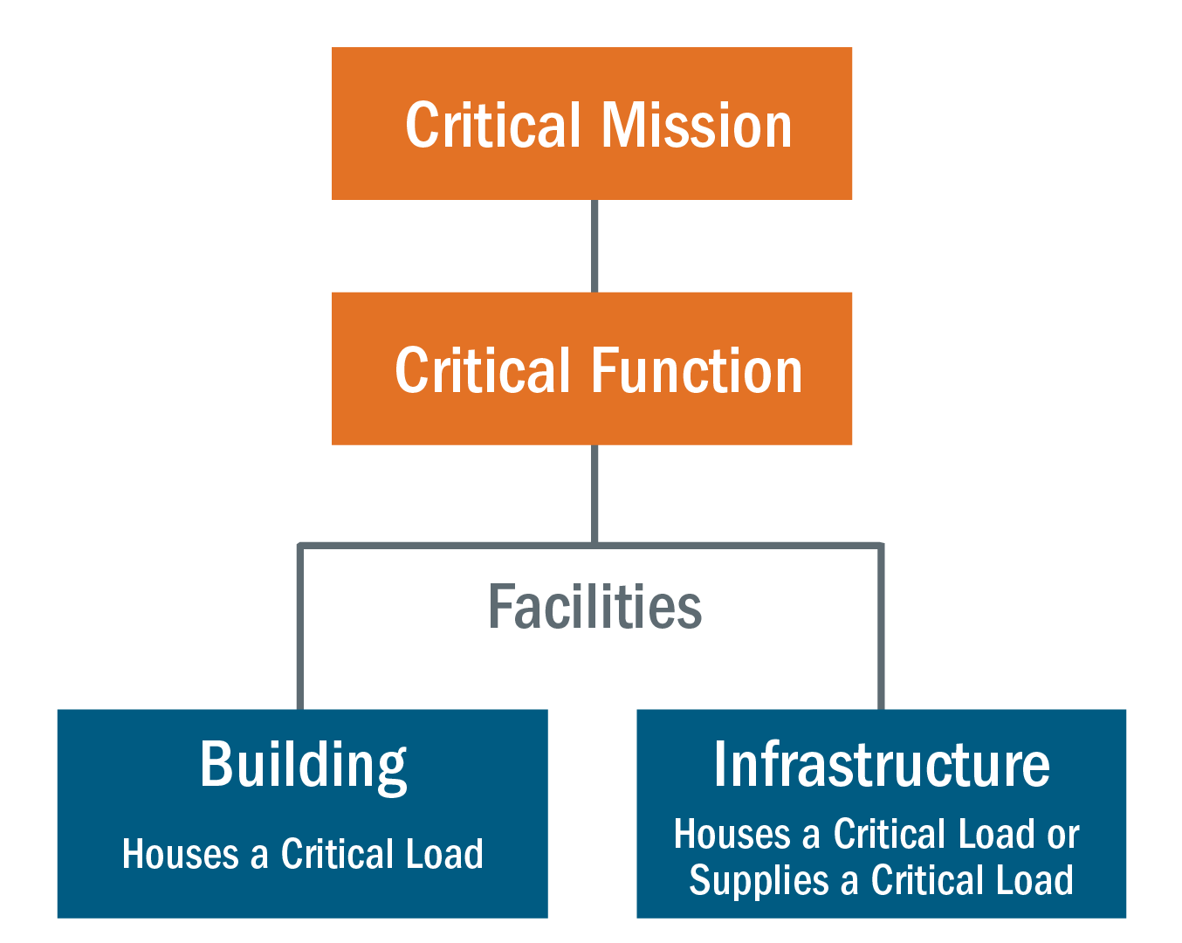
Figure 1: Example of critical missions and functions
There may be multiple critical functions that support a single critical mission or there may be a single critical function for each critical mission. As a part of the identification process, users will need to define which functions enable each critical mission and determine if they are considered critical (or not). In other words, users should ask “If our site lost this function, would we still be able to accomplish the critical mission that it serves?” This can be a confusing process for users who do not already have defined definitions of critical functions at their site. Once critical functions have been identified, users can assign weights to them that reflect how important that function is to accomplish the site’s critical missions.

How to Define Critical Functions: Best Practices
Having a common working definition of a critical function may help ensure that TRN team members are on the same page when identifying or agreeing upon a site’s critical functions within the scope of assessment. To enhance the existing TRN definition, some best practices for thinking about critical functions are discussed below.
“A critical function is not an object,” (Stanislaus 2013).
The TRN defines functions as “operations and activities” (TRN 2022). Objects on their own cannot enable critical missions. An action needs to be attached to an object. For example, “ventilation system” is not a critical function because it is not an operation or activity. Instead, we might have the critical function, “Maintain the lab ventilation system.” To accomplish this critical function, operations and activities will be implemented (Stanislaus 2013).
“A critical function is not the name of an entire department,” (Stanislaus 2013).
Critical functions are accomplished through personnel and resources in a department. Departments may have multiple critical functions to support, or one critical function maybe be supported by multiple departments. As an example, consider the critical function “provide IT training” which is accomplished by the IT department. The IT department may also support the critical function “process and store data.” In this example, using the IT department as a critical function is overly broad and focuses on the resources needed for the multiple critical functions to be accomplished, rather than describing the individual “operations and activities”—the critical functions—that the department supports (Stanislaus 2013 and FEMA 2019). It is important to separate different critical functions for a risk assessment because each function may have a different level of importance for the site’s ability to accomplish its critical missions. By separating critical functions, TRN users are able to reflect these differences in the criticality weights assigned to critical functions.
A critical function is not an entire building or facility.
Similar to the discussion above, multiple buildings can serve the same function, or one building can serve multiple functions. For example, “Research Laboratory” is not a critical function. Depending on the scope of your site, the laboratory may conduct various types of research that are unrelated and serve different critical missions. Instead, the critical functions could be defined as “Analyze groundwater samples” and “Evaluate technologies that could lead to a cyberattack.” Both may be accomplished in the research laboratory, but both serve different missions or represent different levels of criticality, making the laboratory too broad to be a critical function.
To begin identifying your site’s critical functions, consider the following questions:
- What are your site’s critical missions?
- What is the purpose of your site?
- How does your site accomplish critical missions?
- What does your site provide by executing its operations?
- What activities if they are interrupted or fail will result in mission or key activity failure?

Leveraging Existing Policies and Procedures
If site-specific information on critical missions and critical functions is not readily available, users may consider reviewing documentation such as:
- Business continuity plans
- Emergency preparedness plans
  - Workplace safety plans
  - COVID response plans
- Resilience, risk, and vulnerability plans
  - E.g., DOE Vulnerability Assessment and Resilience Plan (VARP); DoD Installation Energy Plan (IEP) or Installation Energy and Water Plan (IEWP)
- Emergency action plans
- Emergency operations procedures (EOPs)
- Continuity of operations plans (COOPs)
- Standard operations procedures (SOPs)
Recall, the TRN defines critical functions as "the operations and activities required to enable a critical mission” (TRN 2022). More definitions of critical functions can be seen in Table 1.
Keep in mind that there might be a different word that your organization or site uses that meets the TRN definition of a critical function. Consider reviewing policies and procedures identified in Site-Level Planning Action 2 with an eye towards the terminology below that, while not called critical functions, may describe operations or activities that can be included in the TRN assessment as “critical functions.”
- Mission critical functions
- Mission essential functions (MEFs)
- Critical business functions
- Support functions
- Functions; occasionally broken down with pre-determined levels of criticality, such as:
  - Critical functions
  - Essential functions
  - Necessary functions
  - Desirable functions
In some cases, there may be defined “mission essential functions” that do not match what is required in the TRN’s definition of a critical function. In that case, TRN users may need to “translate” or “decompose” these functions into sets of operations or activities. For example, a site may have “Building Maintenance” defined as an essential function within their Continuity of Operations Plan (COOP). However, this is not a match for the information needed within the TRN as it more closely aligns to a department rather than a set of activities. In this case, the TRN team may then develop critical functions including:
- Provide proper ventilation
- Provide and maintain utilities connections
- Provide and maintain electrical infrastructure
- Provide and maintain wastewater infrastructure
- Maintain operation of research equipment

Definitions
Different sites may choose to define critical functions slightly differently depending on the sector of the site and the site missions. Below are a few definitions of critical functions.
Table 1: Definitions of Critical Functions
Definitions
Critical functions are “the operations and activities required to enable a critical mission (e.g., a data center’s critical function is to process data for scientific analysis). Critical functions are enabled by critical loads (e.g., a chiller is a load that provides cooling to allow the data center to meet its critical function).” (Technical Resilience Navigator).

“Critical functions are functions your unit normally performs that must continue at a sufficient level without interruption or restart within given time frames after a disruption to the service. If a critical function is not available at a sufficient level within the resumption timeframe, the campus community risks direct and immediate adverse effects in terms of: loss of life, personal injury, loss of property, and/or the University’s ability to maintain direction, control of, or accountability for instruction, research, or services essential to its mission,” (UNC at Chapel Hill).

“A critical function is a service, or a collection of services normally performed by a unit that must continue at a sufficient level without interruption or restart within given timeframes after a disruption to the service,” (Suffolk University).

“A function is critical if it preserves life, presents injury, or protects property; provides indispensable support for provision of other critical functions; is required by law or regulatory authority; cannot suffer a significant interruption; directs or controls instruction or research,” (Kuali 2017).

Examples of Critical Functions
Below are tables providing examples of critical functions divided by theme. This is not a comprehensive list of functions, but rather is meant to provide a starting point for thinking about what types of activities could be identified as critical functions at your site. Some critical functions are listed under multiple themes because they could be relevant for different mission types.

Facility Operations Functions
Examples of Critical Functions | Description
Provide proper ventilation | Ensuring that appropriate ventilation in a facility is installed and operational can protect personnel from hazardous conditions.
Provide and maintain utilities connections (DoD 2008) | Providing and maintaining utilities connections can assist in sustaining baseline site activities and protect the safety of onsite staff.
Provide and maintain electrical infrastructure | Maintaining electrical infrastructure can assist in sustaining baseline site activities, continuing research, and promoting workplace safety.
Maintain manufacturing operations | Maintaining manufacturing operations can support site activities related to the production of materials or commodities.
Upkeep training facilities | Upkeeping training facilities, such as in the military, can assist in sustaining baseline activities by preparing and educating new personnel for site operations.
Manage supplies (DoD 2008) | Managing supplies, for example by procuring and maintain contracts, controlling inventory, providing, and storing shipment information, processing order receipts, and reporting order and inventory status, can assist in sustaining baseline activities (DoD 2008).
Provide and maintain property | Providing and maintaining site property, such as buildings and other infrastructure, can assist in sustaining baseline site activities.
Provide and maintain utilities connections for related remote sites | Providing and maintaining utilities connections for remote sites, such as sites within a national park, can assist in sustaining baseline activities.

Information Technology Functions
Examples of Critical Functions | Description
Maintain data networks (University of North Carolina at Chapel Hill) | Maintaining data networks can ensure online processes are functioning, data is preserved, and communication is open so site operations can continue as usual.
Access and edit electronic records (Dynes et al. 2009) | The ability to access and edit electronic records, such as medical records and site logs, can ensure important recorded information can be obtained to assist clients, provide background information, educate new and existing staff, etc.
Maintain operational site-wide communications (US DHS) | Maintaining communications across a site, such as by telephone or email, can assist in sustaining baseline site activities, connecting employees and clients, and notifying emergency services.
Maintain emergency communications (North Central Texas Council of Governments) | Maintaining emergency communications can support the provision of emergency services, like emergency medical and safety personnel, and allow communication of critical information, such as potential threats or hazards, to community members.
Protect sensitive information (US CISA) | Protecting sensitive information, such as through cybersecurity measures and need to know communication, can assist in maintaining baseline activities and reduce threats and vulnerabilities.
Transport information (DoD 2008) | Transporting information can assist in maintaining baseline activities and reducing threats and vulnerabilities.

Public Health & Healthcare Functions
Examples of Critical Functions | Description
Carry out analyses in drinking water lab facilities (US EPA) | Analyzing drinking water to identify toxins and pathogens in local supplies can help to ensure safety and protect health.
Carry out analytical lab testing of food products (US DHS) | Performing analytical lab testing of food products can help to ensure food safety and protect health.
Manage and treat wastewater (US CISA) | Managing and treating wastewater can support the maintenance and management of infrastructure and the protection of health.
Maintain emergency medical services (Washington Military Department Emergency Management Division 2019) | Maintaining emergency medical services can minimize injuries, reduce health consequences, and minimize the impact of disasters and emergencies on the public.
Preserve lab samples (Dynes et al. 2009) | Preserving medical lab samples, such as keeping samples that require refrigeration at appropriate temperatures and restricting access to potentially harmful samples, can support patient safety and the continuation of care, treatment, and other services.
Order medications and view patient medication profiles (Dynes et al. 2009) | Ordering medication and viewing medication profiles can support patient safety and the continuation of care, treatment, and other medical services.
Preserve patient records (Institute for Crisis, Disaster, and Risk Management 2010) | Preserving medical records can support patient safety and the continuation of care, treatment, and other medical services.
Provide inpatient care (University of North Carolina at Chapel Hill) | Providing inpatient care can support patient safety and the continuation of care, treatment, and other medical services.
Maintain access to medical supplies (DoD 2008) | Providing inpatient care can support patient safety and the continuation of care, treatment, and other medical services.
Provide and maintain utilities connections (DoD 2008) | Providing and maintaining utilities connections can assist in sustaining baseline site activities, such as providing life support in a hospital, and protect the safety of staff and patients.

Research Functions
Examples of Critical Functions | Description
Continue ongoing experiments | Continuing ongoing experiments by ensuring critical loads are operational and necessary resources are available (or can be made available) can help to obtain experimental results in a timely and accurate manner.
Design, develop, and test technologies (DoD 2008) | Continuing research and development by designing, testing, and creating technologies can help to improve current technologies and provide necessary technologies for the site, the organization, or the public.
Conduct data analysis | Conducting data analysis by receiving data and performing analysis activities to provide actionable information to project leads.
Cultivate agricultural samples | Cultivating agricultural samples can assist in the continuation of agricultural experiments. The samples may need operating irrigation systems, fertilization, access to pollinators, protection from severe weather, and safe seed storage.
Preserve experimental components and samples | Preserving experimental components and samples, such as storing chemical components safely, keeping samples that require refrigeration at appropriate temperatures, and restricting access to potentially harmful components can help ensure the continuation of experiments and protect human and environmental health.
Maintain animal living areas | Ensuring that animal subjects used for research purposes are maintained following all required safety, environmental, and other policies.
Store research equipment | Securely storing and maintaining research equipment following all security requirements (e.g., access control) and temperature requirements (e.g., relative humidity).
Obtain and analyze meteorological data | Obtaining and analyzing meteorological data to develop meteorological forecasts.
Provide and communicate meteorological forecasts (US DHS) | Providing and communicating meteorological forecasts, such as alerting populations of hazardous weather, can assist in protecting the public from harm and assist communities and organizations in taking actions to best protect infrastructure from potential damage.

Safety & Security Functions
Examples of Critical Functions | Description
Conduct hazardous waste material response (University of Memphis) | Providing hazardous waste material response services, like properly disposing of radioactive waste, toxic substances, and potentially explosive materials, can support good environmental health and can ensure public safety.
Protect sensitive information (US CISA) | Protecting sensitive information, such as through cybersecurity measures and need-to-know communication, can assist in maintaining baseline activities and reducing threats and vulnerabilities.
Analyze and provide intelligence (TRN 2022) | Analyzing and providing intelligence, such as by collecting and evaluating data, can help provide necessary information to make decisions, maintain current operations, and protect the safety and privacy of clients or the public.
Transport information (DoD 2008) | Transporting information can assist in maintaining baseline activities and reducing threats and vulnerabilities.
Maintain security across site (US DHS) | Maintaining security across a site, such as by ensuring lights remain on, locked doors do not open automatically, sensitive areas have reduced access, and alarms function appropriately can help to protect site staff, employees, and the public.
Provide and communicate meteorological forecasts (US DHS) | Providing and communicating meteorological forecasts, such as alerting populations of hazardous weather, can assist in protecting the public from harm and assist in informing the population on how to best protect infrastructure from potential damage.
Provide and maintain utilities connections (DoD 2008) | Providing and maintaining utilities connections can assist in sustaining baseline site activities and protect the safety of onsite staff.

References
CSU Stanislaus. (2013). Critical Functions Guide. https://www.csustan.edu/sites/default/files/RiskManagement/Documents/guidetocriticalfunctions2013.pdf
Department of Defense. (2008, October 24). Mission-Based Critical Asset Identification Process. Defense Critical Infrastructure Program, 3020.45 Volume 1. https://irp.fas.org/doddir/dod/m3020_45_v1.pdf
Dynes, S., S. Pixley & D. Madory. (2009). Managing Risk of IT Disruptions in Healthcare Settings: A Continuity of Operations Planning Process. AMCIS 2009 Proceedings, 161. https://digitalstrategies.tuck.dartmouth.edu/wp-content/uploads/2016/10/AMCIS09.pdf
FEMA. Small Business Continuity Plan Template. https://arlingtonva.s3.amazonaws.com/wp-content/uploads/2019/08/COOP-Template-Business-Continuity.pdf
Institute for Crisis, Disaster, and Risk Management at the George Washington University. (2010). Emergency Management Principles and Practices for Health Care Systems, 2nd Edition. U.S. Department of Veterans Affairs.
Kuali. (2017, July 20). BCP Webinar: Critical Functions - A Fast-Track Approach. YouTube. https://www.youtube.com/watch?v=Uwo4GYR-xYg
Suffolk University. How to Identify Critical Functions. https://www.suffolk.edu/-/media/suffolk/documents/about/directory/risk-management/how_to_identify_critical_functions_pdftxt.pdf?la=en&hash=849BADEB585C711C0A90A2767FF0B1200F90705D#:~:text=A%20critical%20function%20is%20a,a%20disruption%20to%20the%20service
Technical Resilience Navigator. (2022). Identify Critical Functions. https://trn.pnnl.gov/glossary
University of Memphis. Critical Functions. https://www.memphis.edu/crisis/pdf/memphis_ready_bcp_critical_functions.pdf
University of North Carolina at Chapel Hill. Critical Functions. https://campussafety.unc.edu/emergency-management/tar-heel-mission-ready/user-guide/critical-functions/
US CISA. “National Critical Functions Set.” https://www.cisa.gov/national-critical-functions-set
US DHS. List of Validated PMEFs by Department/Agency. https://www.dhs.gov/sites/default/files/publications/list_of_validated_pmefs_by_department_v2_fema.pdf
U.S. Environmental Protection Agency. (2013). Continuity of Operations Plan Template for Drinking Water and Wastewater Laboratories. https://www.epa.gov/sites/default/files/2015-08/documents/coop_template_instructions.pdf
North Central Texas Council of Governments. Infrastructure Recovery Template. https://www.nctcog.org/getmedia/9009337c-0358-48bb-be14-c96f0925bfb2/Infrastructure-Recovery-Support-Function-Template.pdf
Washington Military Department Emergency Management Division. (2019). Comprehensive Emergency Management Plan. https://mil.wa.gov/asset/5cffcfb965217

