TRN Resource: Roadmap to Action Components
In the Roadmap to Action module, the team will move from solution level to project level, then view the process from a funding perspective. The images and green arrows below will help the resilience planning team keep the big picture in mind while identifying the focus of each action.
Action 1: Define Projects for Solution Implementation
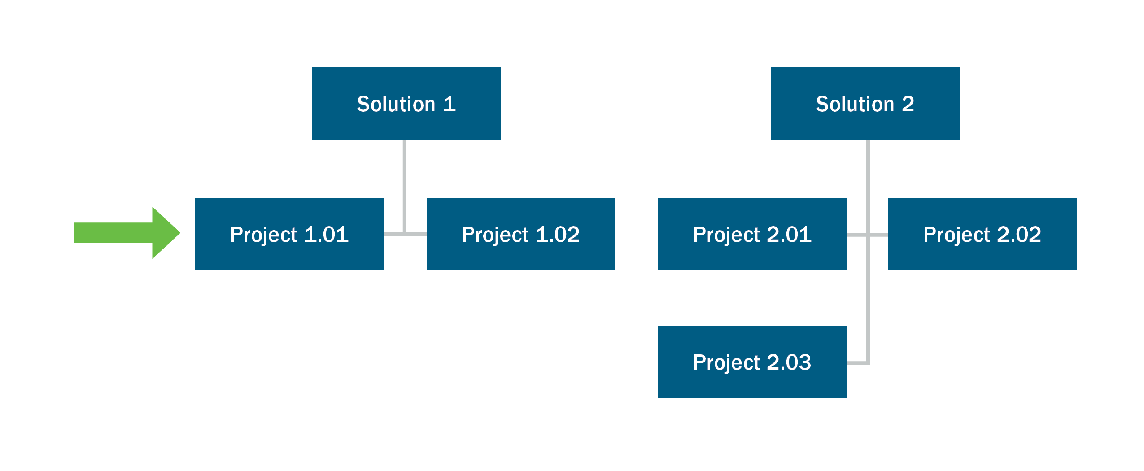

Action 2: Evaluate Potential Funding Sources

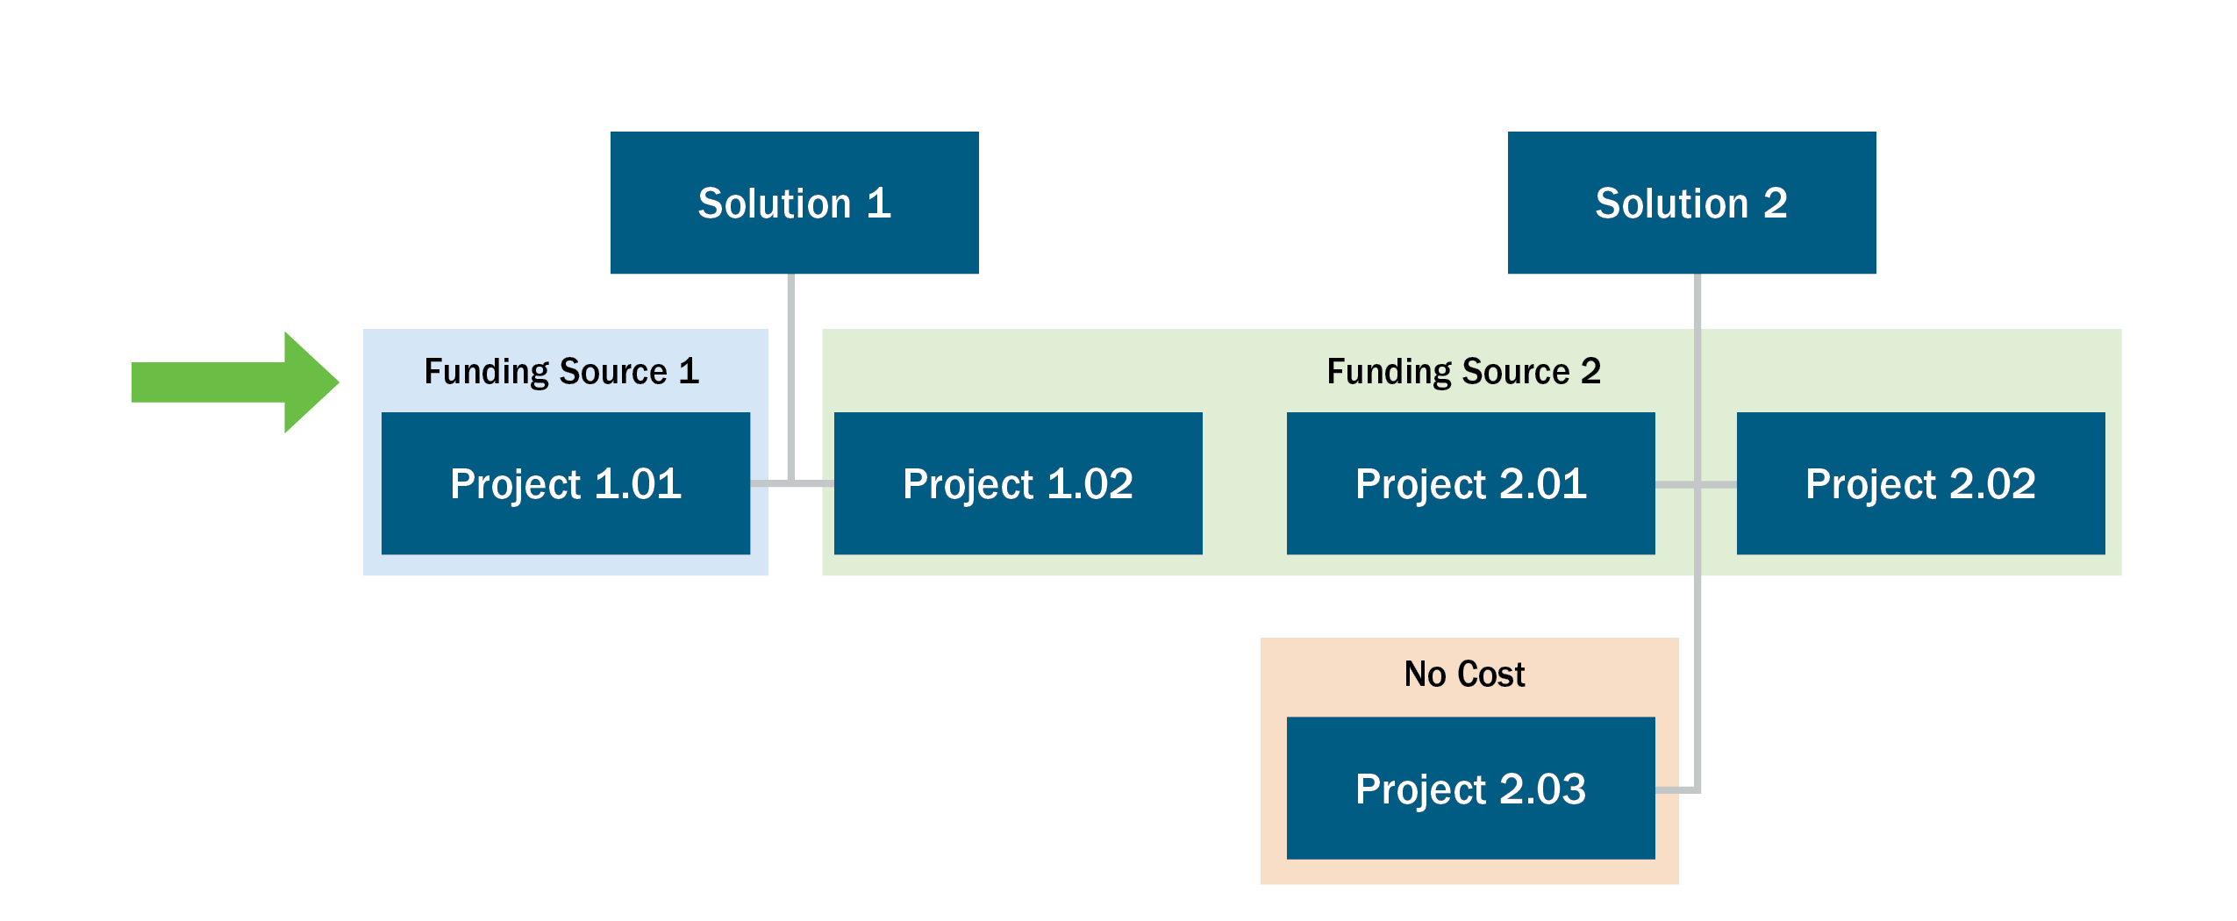

Action 3: Create the Business Justification
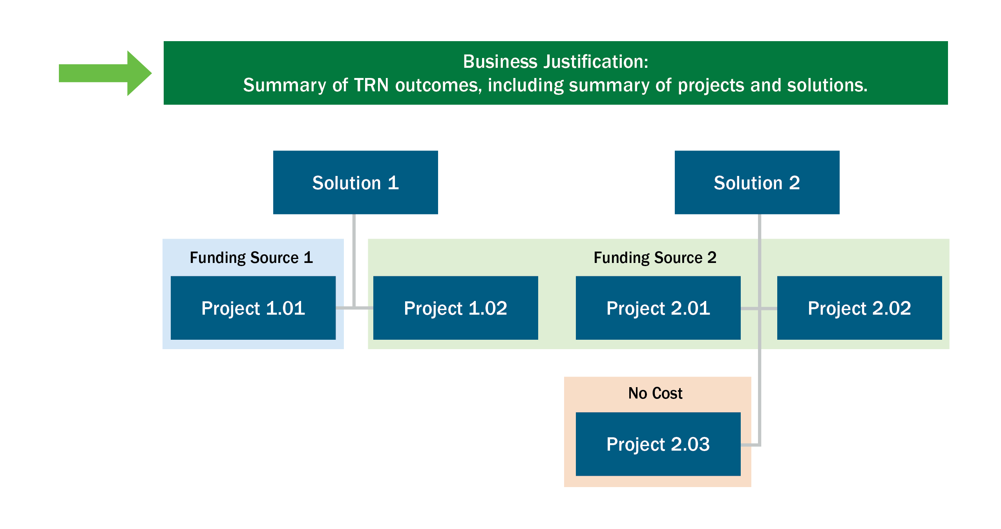

Action 4: Create an Execution Plan
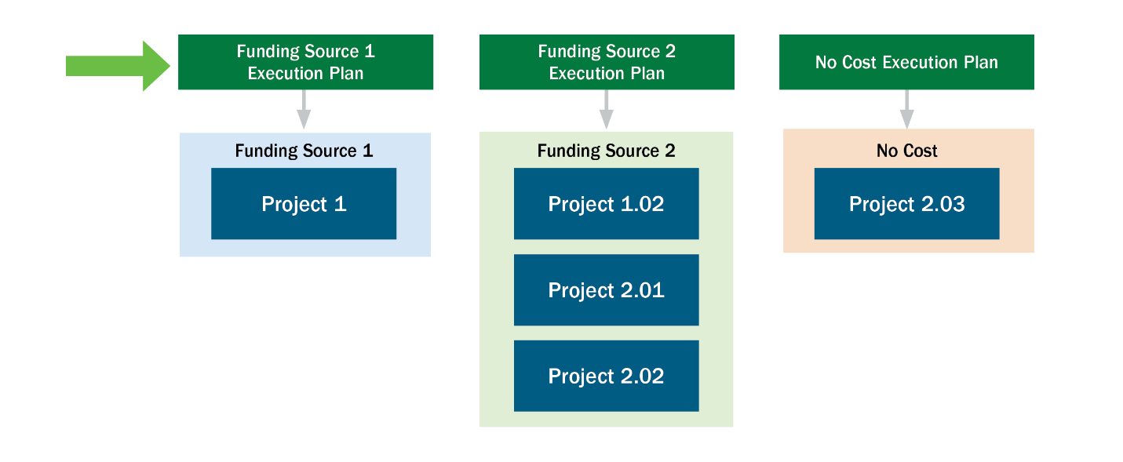

Action 5: Implement and Sustain Resilience
